Regulations:
A18

H.T No

Sreenidhi Institute of Science and Technology
(An Autonomous Institution)
Code No: 7A201 Date: 27-Jan-2020 (FN)

B.Tech I-Year II-Semester External Examination, Jan/Feb-2020 (Supplementary)
ELECTRICAL CIRCUITS AND NETWORKS-I (EEE)

Time: 3 Hours Max.Marks:70

Note: a) No additional answer sheets will be provided.
b) All sub-parts of a question must be answered at one place only, otherwise it will not be valued.
c) Missing data can be assumed suitably.

Part - A Max.Marks:20

Answer all QUESTIONS.

1. | Define the terms Current and Voltage. | [2M]
2. | Distinguish the advantages and disadvantages of tie-set matrix? | [2M]
3. | Derive the equation for mutual inductance. | [2M]
4. | Define the terms Impedance and Phase angle. | [2M]
5. | Derive the impulse response of Series RC circuit | [2M]
6. | List out the applications and limitations of Millman’s theorem. | [2M]
7. | What is the dual network? Give one example. | [2M]
8. | Two coupled coils with self inductances of 1H and 2H are connected in series aiding. The resulting inductance L_{eq} is 4H. Find the coefficient of coupling between them. | [2M]
9. | Mention some salient features of Tellegen’s theorem. | [2M]
10. | Comment briefly on the choice between loop and node methods of analyzing a network. | [2M]

Part – B Max.Marks:50
ANSWER ANY FIVE QUESTIONS. EACH QUESTION CARRIES 10 MARKS.

11. | a) | Find the power loss in 2Ω resistor of the network shown below using nodal analysis.  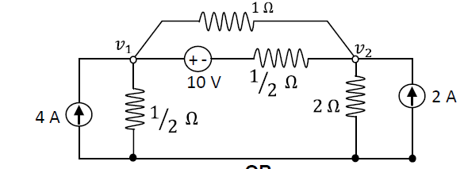 | [7M]
 | b) | Explain the concept of super mesh and super node with example. | [3M]
12. | a) | Prove that in a linear graph, every cut-set has an even number of branches in common with every loop. | [7M]
 | b) | Define the following terms w.r.t network Graph theory:  i) Connected graph ii) Tree iii) Links | [3M]
13. | a) | Obtain an expression for coefficient of coupling. | [5M]
 | b) | Two similar coils connected in series gave a total inductance of 600mH and when one of the coil is reversed, the total inductance is 300mH. Determine the mutual inductance between the coils and coefficient of coupling. | [5M]
14. |  | The impedances of a parallel circuit are Z₁=(6+j8)Ω and Z₂=(8-j6)Ω. If the applied voltage is 120V,  find  (i) current and power factor of each branch  (ii) overall current and power factor of the combination  (iii) power consumed by each impedance.  (iv) Draw a phasor diagram. | [10M]
15. | a) | List the different properties of series and parallel resonant circuits | [5M]
 | b) | Define and explain the concept bandwidth and Q-factor. | [5M]
16. |  | Find the current through 8Ω resistance for the network shown using Thevenin’s theorem.  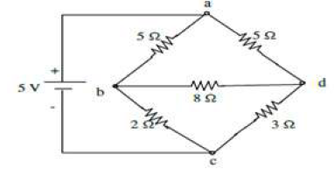 | [10M]
17. | a) | Derive the relations of resistances in star-to-delta transformation. | [5M]
 | b) | Explain the Faraday’s law of electromagnetic induction and list its applications. | [5M]
18. |  | Using superposition theorem, find the current through the link that is to be connected between terminals a-b. Assume the link resistance to be zero.  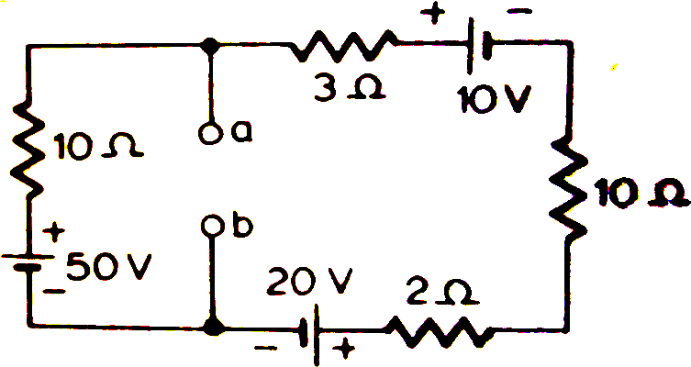 | [10M]

-- 00 -- 00 –

